Lesson 13.06.2024

1. Create pod via deployment with nginx in your local kind cluster

Use kind to create local k8s cluster(default name kind)

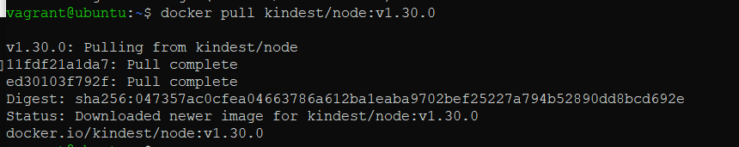

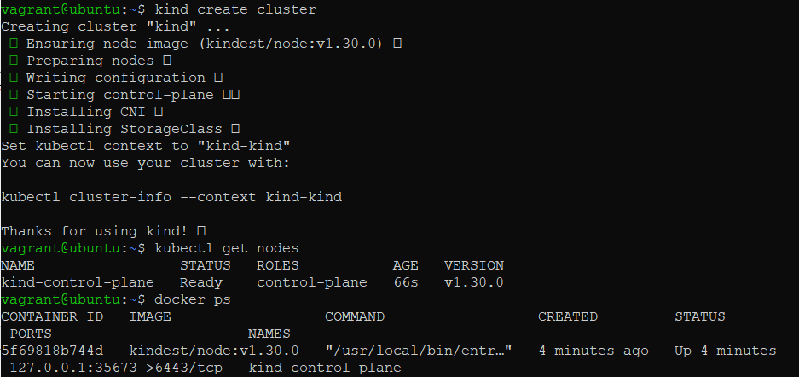

Apply manifest for nginx(file with nginx-hello is hello.yaml)



Create namespace “test” via manifest file

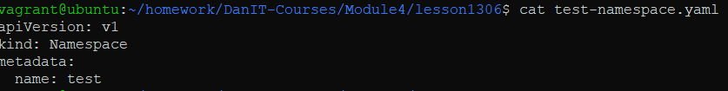

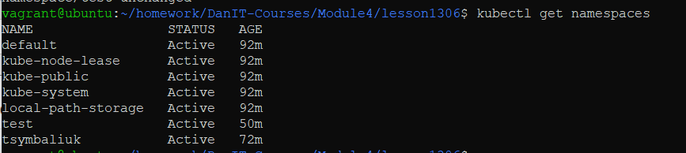

Check pods

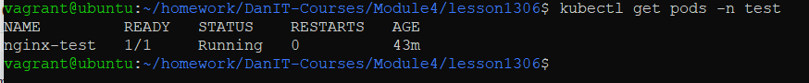

1. Use port-forward to connect to it



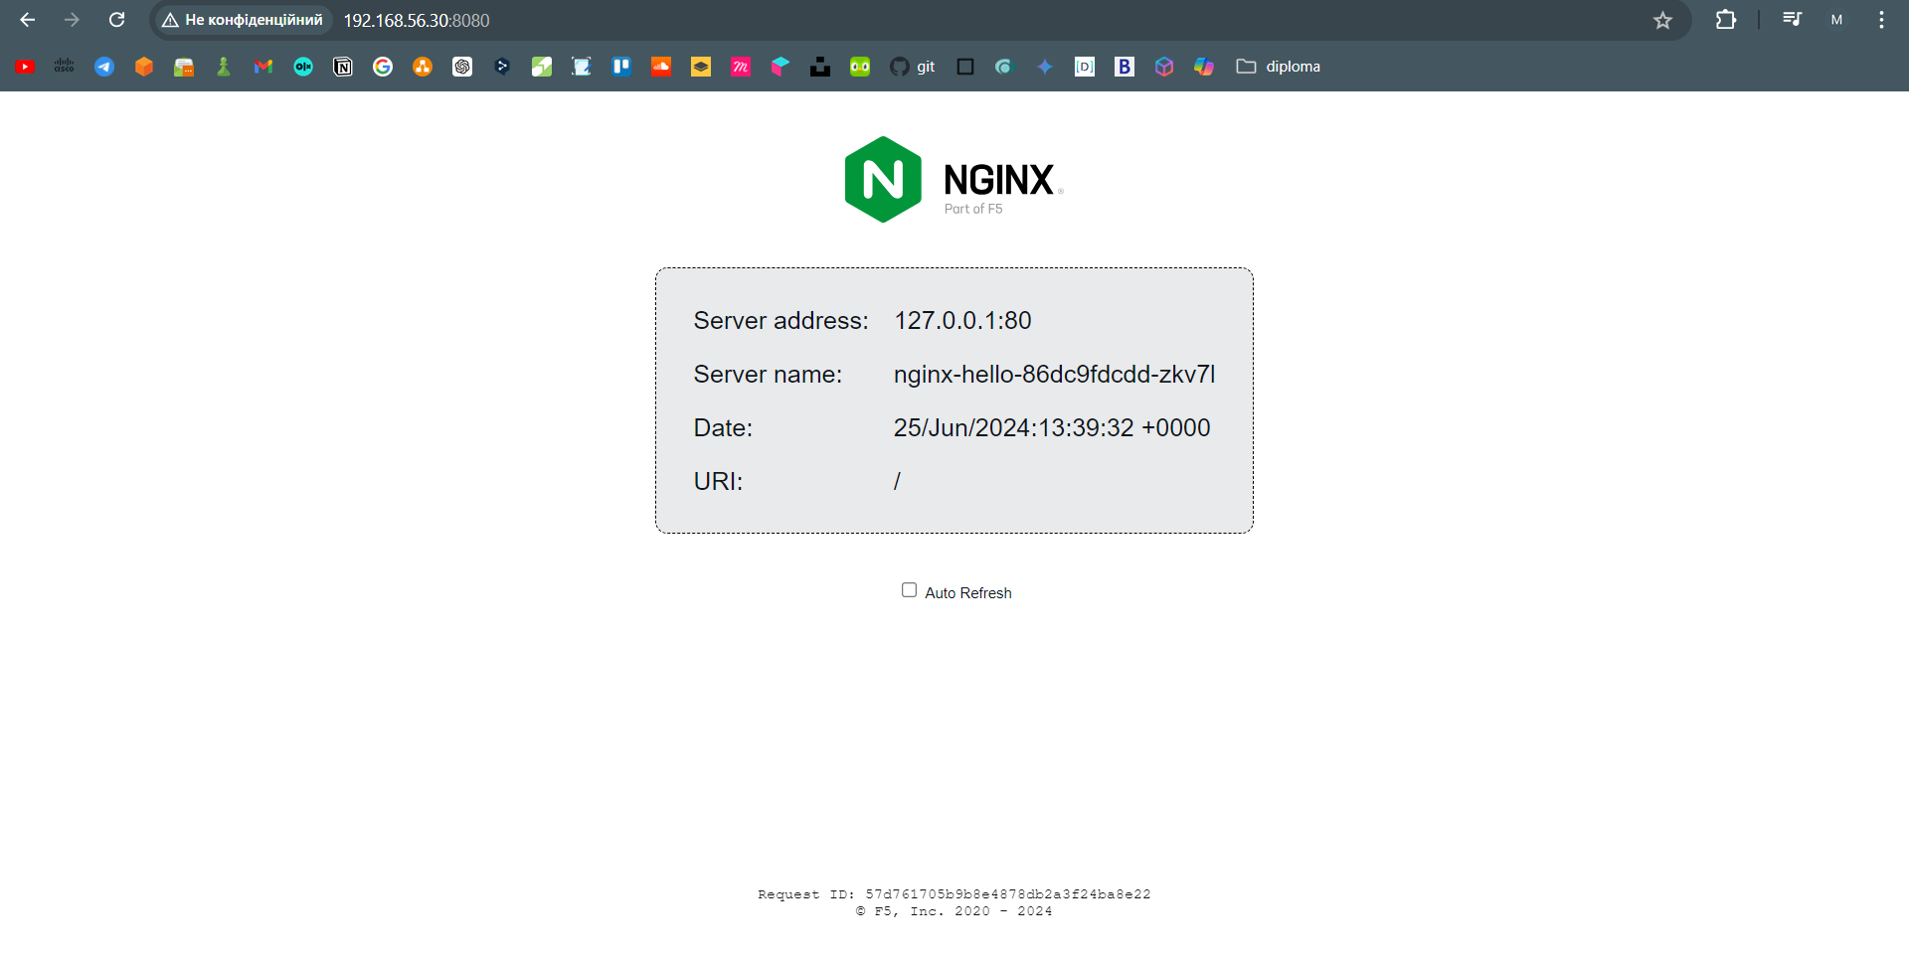

1. Connect to pod container and change index.html to something else, config you can see new content

